Pac-Man API Specification

COMP 504 Chaos

1. Class AEntity
   1. edu.rice.comp504.chaos.model.entities.AEntity
   2. All Implemented Interfaces: java.io.Serializable, java.lang.Cloneable
   3. Direct Known Subclasses: Ghost, PacMan
   4. public abstract class AEntity

extends java.lang.Object

implements java.lang.Cloneable, java.io.Serializable

* 1. Description: An entity which is in the game.
  2. Fields:

|  |  |  |
| --- | --- | --- |
| Modifier and Type | Field | Description |
| private Coordinate | coord | The coordinate in the maze. |
| private Direction | dir | The orientation, intended moving direction. |
| private Coordinate | loc | The location (px, px) on the canvas. |
| private int | remainLength | When the entity has arrived at a regular spot and try to make a decision, the distance it still has to move. |
| private int | size | The length of the entity. |
| private int | speed | The speed of moving. |
| private Direction | startDir | The orientation of it when the game starts. |
| private Coordinate | startLoc | The location of it when the game starts. |

* 1. Constructor:

|  |  |  |
| --- | --- | --- |
| Constructor | Parameters | Description |
| AEntity​(Coordinate startLoc, int speed, int size, Direction dir) | startLoc - the initial Coordinate of the entity.  speed - the speed of the entity.  size - the size of the entity.  dir - the initial direction. | The constructor. To produce an entity with some specific information. |

* 1. Methods:

|  |  |  |  |  |
| --- | --- | --- | --- | --- |
| Modifier and Type | Method | Parameters | Returns | Description |
| (package private) Coordinate | computeIntendedDestination() |  | the intended destination | Compute the intended destination according to the location, speed and direction. |
| Coordinate | getCoord() |  | the Coordinate | Get the Coordinate. |
| Direction | getDir() |  | the direction | Get the direction. |
| private int | getItemOnIntendedDirection() |  | the item | Get the item on the next intended position. |
| Coordinate | getLoc() |  | the location | Get the location. |
| (package private) int | getSpeed() |  | the speed | Get the speed of the entity. |
| private Coordinate | getStartLoc() |  | the initial location | Get the initial location. |
| abstract void | move() |  |  | Move to intended destination or stop. |
| (package private) void | move​(int length) | length - the length |  | Move a certain distance. |
| (package private) void | move​(Coordinate destination) | destination - a specific destination |  | Move to a specific destination. |
| (package private) void | moveOnRegularSpot() |  |  | Move on the regular spot. |
| (package private) void | moveToCoord​(Coordinate destination) |  |  | Move to a specific Coordinate. |
| void | resetLoc() |  |  | Rest the entity to its initial location. |
| void | setDir​(Direction dir) | dir - the direction |  | Set the direction. |
| (package private) void | setDirection​(Direction dir) | dir - the intended direction |  | Set the intended direction of the entity. |
| private void | setLoc​(Coordinate loc) | loc - the location |  | Set the location. |
| void | setSpeed​(int speed) | speed - the speed |  | Set the speed of the entity. |

1. Class AGhostPersonality
   1. edu.rice.comp504.chaos.model.personalities.AGhostPersonality
   2. Direct Known Subclasses: Ambusher, Bashful, Chaser, Pokey
   3. public abstract class AGhostPersonality

extends java.lang.Object

* 1. Description: The personality of a ghost.
  2. Fields:

|  |  |  |
| --- | --- | --- |
| Modifier and Type | Field | Description |
| private PacMan | pm | The reference of the PacMan. The ghost will need the location and orientation of PacMan to make decisions. |

* 1. Constructor:

|  |  |  |
| --- | --- | --- |
| Constructor | Parameters | Description |
| AGhostPersonality​(PacMan pm) | pm - the reference of the PacMan. | Constructor. No matter what the concrete personality is, the ghost must know the Coordinate of the PacMan. |

* 1. Methods:

|  |  |  |  |  |
| --- | --- | --- | --- | --- |
| Modifier and Type | Method | Parameters | Returns | Description |
| (package private) Coordinate | getPacManCoord() |  | the Coordinate | Get the Coordinate of the PacMan. |
| (package private) Direction | getPacManDirection() |  | the direction | Get the direction of the PacMan. |
| abstract IGhostStrategy | think​(Ghost context) | context - the ghost | the strategy | Come up with a strategy, according to different personalities. |

1. Interface IGhostStrategy
   1. All Known Implementing Classes: RandomStrategy, TargetStrategy
   2. public interface IGhostStrategy
   3. Description: The strategy determines how ghosts will take actions.
   4. Methods:

|  |  |  |  |  |
| --- | --- | --- | --- | --- |
| Modifier and Type | Method | Parameters | Returns | Description |
| Direction | choose​(Coordinate current, java.util.List<Direction> availableDirections) | availableDirections - all available directions | the chosen one | Ghosts choose a direction from all available directions, according to different strategy. |

1. Extensibility
   1. User Extensibility

We are going to support 2-player mode in our next version. Users could choose between Single / Duo and this shows our user extensibility.

* 1. Design for Extensibility
     1. We store map and food information (dots, energizers, fruits) as matrix in the txt files and when the game loads, the Game class would read them. So, in order to change the map, we just need to replace the map txt file; in order to change food information, we just need to replace the food map txt file.
     2. We use Object-Oriented-Programming, so that extra Pac-Men and ghosts could be added simply by calling their constructors.

1. Use Case
   1. Use Case Diagram

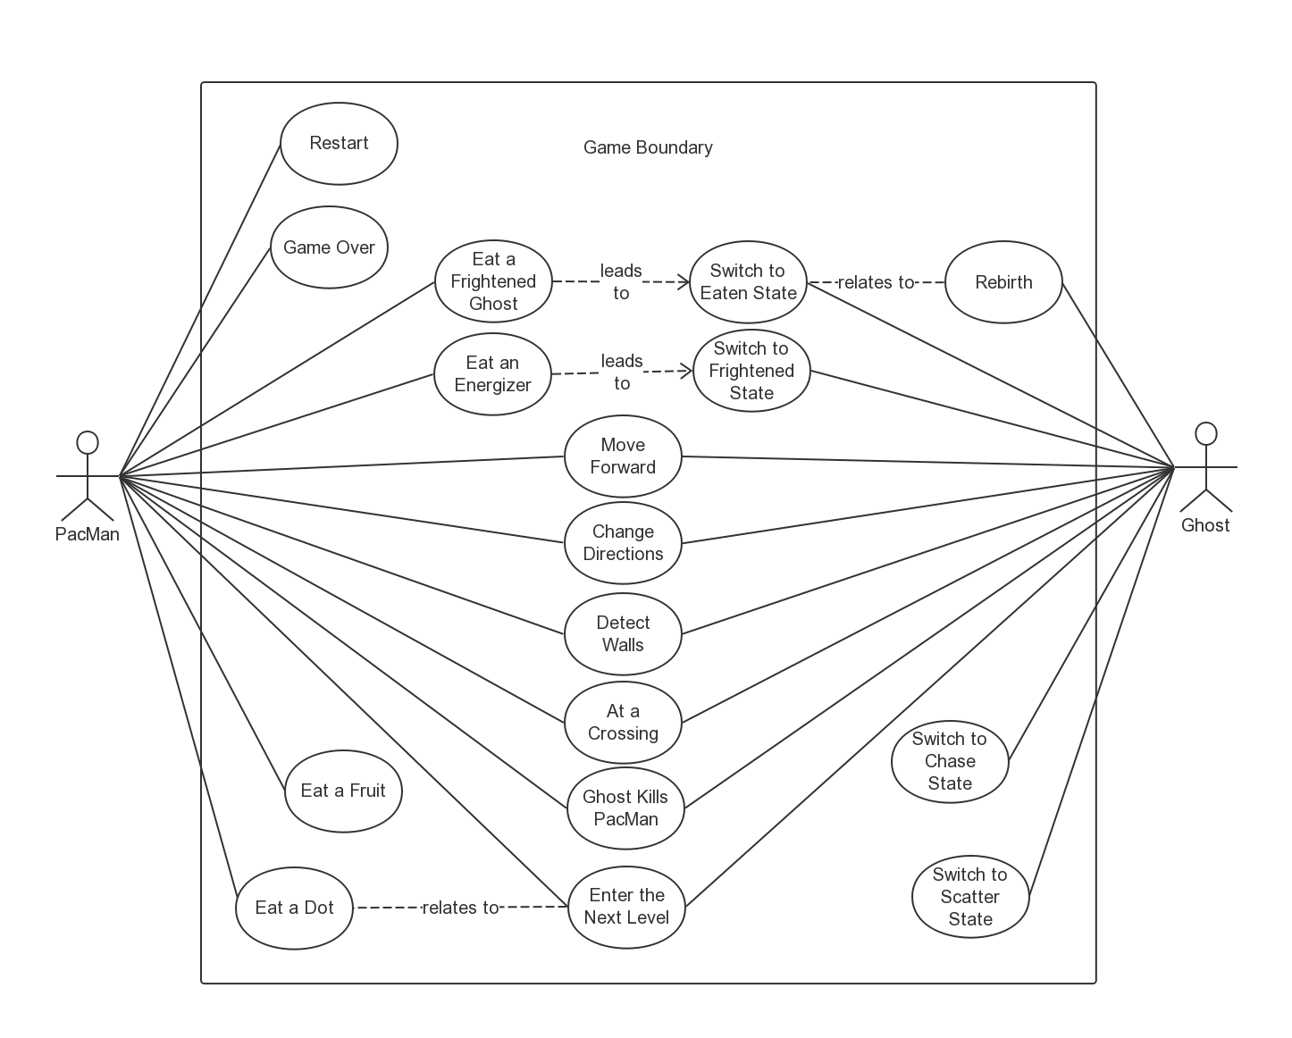

* 1. Use Cases

|  |  |
| --- | --- |
| Name | Move Forward |
| Identifier | UC01 |
| Actors | PacMan, Ghost |
| Description | Entity move towards its direction. |
| Triggers | Time. |
| Preconditions | The game is started.  There is no wall ahead of the entity. |
| Post Conditions | The location of the entity changes. |
| Frequency | Once every 0.1 seconds. |
| Basic Flow | 1. The entity keeps moving. |
| Alternates | N/A |
| Exceptions | When there is a wall ahead, the entity stops. |

|  |  |
| --- | --- |
| Name | Change Directions |
| Identifier | UC02 |
| Actors | PacMan, Ghost |
| Description | Change the moving direction of the entity. |
| Triggers | N/A |
| Preconditions | The game is started.  There is no wall in the new direction. |
| Post Conditions | The entity turns to a new direction. |
| Frequency | Around once every 5 seconds. |
| Basic Flow | 1. If the player enters “↑”, the entity goes up. 2. If the player enters “↓”, the entity goes down. 3. If the player enters “←”, the entity goes left. 4. If the player enters “→”, the entity goes right. |
| Alternates | If there exists a second player, use “W” for up, “S” for down, “A” for left, “D” for right.  For ghosts, the new direction is based on their moving states, their personalities, and the target. |
| Exceptions | When there exists a wall in the new direction, this operation does not work. |

|  |  |
| --- | --- |
| Name | Detect Walls |
| Identifier | UC03 |
| Actors | PacMan, Ghost |
| Description | Detect if there is a wall ahead. |
| Triggers | N/A |
| Preconditions | The game is started. |
| Post Conditions | Return a boolean value. |
| Frequency | Once the entity changes its location or direction. |
| Basic Flow | 1. Get the direction and location of the entity. 2. Return whether there is a wall ahead. |
| Alternates | N/A |
| Exceptions | N/A |

|  |  |
| --- | --- |
| Name | At a Crossing |
| Identifier | UC04 |
| Actors | PacMan, Ghost |
| Description | Decide whether the entity is at a crossing. |
| Triggers | Around once every 5 seconds. |
| Preconditions | The game is started. |
| Post Conditions | Return the crossing situation. |
| Frequency | Once the entity changes its location. |
| Basic Flow | 1. Get the location of the entity. 2. Return the crossing situation. |
| Alternates | N/A |
| Exceptions | N/A |

|  |  |
| --- | --- |
| Name | Ghost Kills PacMan |
| Identifier | UC05 |
| Actors | PacMan, Ghost |
| Description | The Ghost eats the PacMan. |
| Triggers | The Ghost and the PacMan overlap with each other. |
| Preconditions | The game is started.  The ghost is in Scatter or Chase state. |
| Post Conditions | The PacMan dies. |
| Frequency | It depends. |
| Basic Flow | 1. The PacMan and the ghost overlap with each other. 2. The PacMan dies. |
| Alternates | N/A |
| Exceptions | N/A |

|  |  |
| --- | --- |
| Name | Enter the Next Level |
| Identifier | UC06 |
| Actors | PacMan, Ghost |
| Description | The game enters the next level, which is more difficult. |
| Triggers | All dots are eaten up by the PacMan |
| Preconditions | The game is started. |
| Post Conditions | The game enters the next level. |
| Frequency | It depends. |
| Basic Flow | 1. When all dots are cleared, the game goes to the next level. |
| Alternates | N/A |
| Exceptions | N/A |

|  |  |
| --- | --- |
| Name | Eat a Dot |
| Identifier | UC07 |
| Actors | PacMan |
| Description | Move the PacMan and eat a dot. |
| Triggers | The PacMan and the dot are overlap with each other. |
| Preconditions | The game is started. |
| Post Conditions | When all dots are cleared, the game goes to the next level. |
| Frequency | No more than 240 times each level. |
| Basic Flow | 1. PacMan moves. 2. When the PacMan is over the dot, the dot is eaten. 3. When all dots are cleared, the game goes to the next level |
| Alternates | N/A |
| Exceptions | N/A |

|  |  |
| --- | --- |
| Name | Eat a Fruit |
| Identifier | UC08 |
| Actors | PacMan |
| Description | The PacMan eats a fruit. |
| Triggers | The PacMan and the fruit are overlap with each other. |
| Preconditions | The game is started.  There are some fruits on the map. |
| Post Conditions | The PacMan gets some bonus credits. |
| Frequency | It depends. |
| Basic Flow | 1. PacMan moves. 2. When the PacMan is over the fruit, the fruit is eaten. |
| Alternates | N/A |
| Exceptions | N/A |

|  |  |
| --- | --- |
| Name | Eat a Frightened Ghost |
| Identifier | UC09 |
| Actors | PacMan |
| Description | PacMan eats the ghosts and changes ghosts into eaten mode. |
| Triggers | The PacMan and the ghost are overlap with each other. |
| Preconditions | The game is started.  Ghosts are in the frightened state. |
| Post Conditions | Frightened ghosts turn into the eaten state and run back to the ghost home.  PacMan gets additional points. |
| Frequency | It depends. |
| Basic Flow | 1. Move the PacMan and overlap itself with the frightened ghosts. 2. Frightened ghosts which are eaten turn into the eaten state. |
| Alternates | N/A |
| Exceptions | N/A |

|  |  |
| --- | --- |
| Name | Eat an Energizer |
| Identifier | UC10 |
| Actors | PacMan |
| Description | Move the PacMan and eat an energizer. |
| Triggers | The PacMan and the energizer are overlap with each other. |
| Preconditions | The game is started.  There are some energizers left on the map. |
| Post Conditions | All ghosts turn into the frightened state. |
| Frequency | No more than the-number-of-energizers times each level. |
| Basic Flow | 1. PacMan moves. 2. When the PacMan is over the energizer, the energizer is eaten. |
| Alternates | N/A |
| Exceptions | N/A |

|  |  |
| --- | --- |
| Name | Game Over |
| Identifier | UC11 |
| Actors | PacMan |
| Description | The game is over. |
| Triggers | UC05 |
| Preconditions | There is no life left for the PacMan. |
| Post Conditions | Words “Game Over” appears. |
| Frequency | It depends. |
| Basic Flow | 1. Words “Game Over” appears. |
| Alternates | N/A |
| Exceptions | N/A |

|  |  |
| --- | --- |
| Name | Restart |
| Identifier | UC12 |
| Actors | PacMan |
| Description | Restart the game. |
| Triggers | The PacMan is eaten by a ghost. |
| Preconditions | There are still lives left. |
| Post Conditions | PacMan goes back to its birth place.  Ghosts go back to their home.  The number of lives minus 1 |
| Frequency | It depends. |
| Basic Flow | 1. PacMan goes back to its birth place. 2. Ghosts go back to their home. 3. The number of lives minus 1 |
| Alternates | N/A |
| Exceptions | N/A |

|  |  |
| --- | --- |
| Name | Switch to Scatter State |
| Identifier | UC13 |
| Actors | Ghost |
| Description | Ghost switches to Scatter state. |
| Triggers | It is the scatter time period now. |
| Preconditions | The game is started. |
| Post Conditions | Ghost switches to Scatter state. |
| Frequency | About once every 10 seconds. |
| Basic Flow | 1. The ghost changes its target. |
| Alternates | N/A |
| Exceptions | N/A |

|  |  |
| --- | --- |
| Name | Switch to Chase State |
| Identifier | UC14 |
| Actors | Ghost |
| Description | Ghost switches to Chase state. |
| Triggers | It is the Chase time period now. |
| Preconditions | The game is started. |
| Post Conditions | Ghost switches to Chase state. |
| Frequency | About once every 10 seconds. |
| Basic Flow | 1. The ghost changes its target |
| Alternates | N/A |
| Exceptions | N/A |

|  |  |
| --- | --- |
| Name | Switch to Frightened State |
| Identifier | UC15 |
| Actors | Ghost |
| Description | Ghost switches to Frightened state. |
| Triggers | UC10 |
| Preconditions | The game is started. |
| Post Conditions | Ghost switches to Frightened state. |
| Frequency | It depends. |
| Basic Flow | 1. The ghost changes its appearance. 2. The ghost changes its speed. |
| Alternates | N/A |
| Exceptions | N/A |

|  |  |
| --- | --- |
| Name | Switch to Eaten State |
| Identifier | UC16 |
| Actors | Ghost |
| Description | Ghost switches to Eaten state. |
| Triggers | UC 09 |
| Preconditions | The game is started. |
| Post Conditions | Ghost switches to Eaten state. |
| Frequency | It depends. |
| Basic Flow | 1. The ghost changes its appearance. 2. The ghost goes back to ghost home. |
| Alternates | N/A |
| Exceptions | N/A |

|  |  |
| --- | --- |
| Name | Rebirth |
| Identifier | UC17 |
| Actors | Ghost |
| Description | The Eaten ghost recovers in the ghost home. |
| Triggers | The ghost is in the ghost home. |
| Preconditions | The ghost is in the Eaten state. |
| Post Conditions | The ghost recovers. |
| Frequency | Once the ghost is eaten. |
| Basic Flow | 1. The ghost changes back to its original appearance. |
| Alternates | N/A |
| Exceptions | N/A |